# **Compression algorithms to optimize battery consumption in precision livestock farming**

|  |  |  |  |
| --- | --- | --- | --- |
| Hernan Moreno  Universidad Eafit Colombia hmorenom@eafit.edu.co | Mariana Yepes  Universidad Eafit Colombia myepesa@eafit.edu.co | Simón Marín Universidad Eafit Colombia smaring1@eafit.edu.co | Mauricio Toro  Universidad Eafit  Colombia  mtorobe@eafit.edu.co |

# **Abstract**

Most of the protein consumed by mankind comes from livestock, and its demand is increasing day by day, despite efforts to develop artificial proteins to replace it in the future [1]. Energy consumption on livestock farms is an obstacle to the use of technological tools to optimize processes. That is why it is important to facilitate the use of image compression algorithms for use in livestock farms to detect animal health, minimizing the use of computational and energy resources, thus reducing costs and optimizing the cattle raising process.

## **Key words**

Compression algorithms, machine learning,

deep learning, precision livestock, animal health.

# **Introduction**

Precision Livestock farming (PLf) refers to the application of technology to a livestock farm in order to optimize herd management and minimize operating costs. A system of digital cameras at certain points where cattle pass through the herd, allows an analysis of the health of each animal based on its physical appearance. However, the images generate a high volume of data that consumes valuable resources (disk storage, energy, time) and therefore it is necessary to develop a compression algorithm without loss of image quality

# **Problem**

Most published forecasts predict that global demand for meat will increase by at least 40% in the next 15 years [1]. At the same time, there is great concern about the transfer of diseases from livestock to humans, which makes animal health a high priority. Furthermore, there is great room for improvement in the treatment of animal diseases. for example, the use of anti-biotics is too high and needs to be reduced. The problem we face is to design an algorithm to compress the Cattle images taken in the field to determine through their analysis the health of the animals. The algorithm must consume as little energy and computational power as possible to optimize the available resources. In addition, it should be possible to revert to the original image when necessary.

**1.2 Solution**

In this work, we used a convolutional neural network to classify animal health, in cattle, in the context of precision livestock farming (PLF). A common problem in PLF is that networking infrastructure is very limited, thus data compression is required.

**1.3 Article structure**

In what follows, in Section 2, we present related work to the problem. Later, in Section 3, we present the data sets and methods used in this research. In Section 4, we present the algorithm design. After, in Section 5, we present the results. Finally, in Section 6, we discuss the results, and we propose some future work directions.

1. **RELATED WORK**

In what follows, we explain four related works on the domain of animal-health classification and image compression in the context of PLF.

**3.1 Abundance of unstructured information, and therefore difficult to apply. [20]**

A clear example is given in Australia, and it is a model based on the Hazard Analysis Critical Control Point (HACCP) method, developed for cattle grazing companies, and which can be applied to other industries in the animal sector. It is based on the following:

a. Identifying those aspects that have a major effect on productivity, profitability and/or sustainability: actions that, if not carried out correctly, will substantially reduce the viability of the enterprise. In the Australian case, 29 aspects were identified that met this condition.

b. Identify for each of the above processes the variables to be measured to ensure that the process is carried out correctly.

c. Apply the most cost-effective corrective action whenever the measurements are outside the predetermined limits.

d. Establish Standard Operating Procedures (SOP) for specific companies and for each essential procedure to ensure that, under normal circumstances, the critical values measured will be within the predetermined limits.

e. Provide the necessary tools to perform the measurements, interpret them, and decide on corrective actions. This is the "package" of the solution and farm personnel should be trained in its use.

**3.2 Wireless network for livestock health monitoring. [19]**

The agriculture and livestock industry are of vital importance in the UK, with an annual output in the order of £5.8 billion. About ¾ of the kingdom's land is devoted to agriculture and livestock farming and employs about 500,000 people. In recent years there have been serious diseases. The two most recent were BSE (Bovine Spongiform Encephalopathy) and FMD (Foot and mouth disease) in 1986 and 2001 respectively. 4.5 million cattle were incinerated following the identification of BSE and nearly 4 million for FMD, at a total cost to the British economy of some £13 billion.

The main issues for a Wireless Monitoring System are:

a. Signal attenuation due to the animal's body: this is due to the absorption of the radio signal by the bodies of the animals in the herd.

b. Low memory capacity in the nodes: this makes it not possible to store the information to send it later. It is therefore necessary to develop a routing protocol to send the information in real time to the base station via multi-hop.

## c. Mobility: Wireless monitoring networks are normally static. In a cattle herd the cattle are in continuous movement and therefore the sensors are in continuous movement. Therefore, the network topology and routing configuration must be dynamic to adapt to changes in the position of the cattle and sensors.3.3 Write a title for the third related problem

## **3.3 Analysis of individual classification of lameness using automatic measurement of back posture in dairy cattle**

## This paper presents an algorithm for automatic camera analysis of dairy cows as they approach a milking robot. By performing image analysis and calculating the model parameters from the image information, it was possible to develop this algorithm for automatic detection of lameness problems in dairy cows. These techniques allow a frequent and fully automatic follow-up of each cow, a process that can no longer be easily performed by the farmer. As soon as the calculated individual performance parameters change, a warning alerts the farmer. This can have important benefits, because lameness is a major welfare problem in modern dairy cows, where up to 25% can be severely affected.

The algorithm seeks to calculate the BMP or body movement pattern. The highest point (R) of the total curvature of the animal's back was used as a starting point to calculate the BMP. Two ellipses were fitted to the left and right sides of the point R and their orientation, θ1 and θ2, was calculated. The intersection between the two lateral axes of both ellipses was determined and the resulting angle, θ3, was calculated; L2 is the vertical distance between this intersection point and R. A line was drawn joining the position of the cow's snout to the longitudinal axis of the front ellipse; L1 is the vertical distance between the cow's snout and the longitudinal axis of the front ellipse. The angle θ4, between the horizontal line joining L1 with the longitudinal axis of the frontal ellipse and the line joining the cow's snout with the longitudinal axis of the frontal ellipse, was calculated.

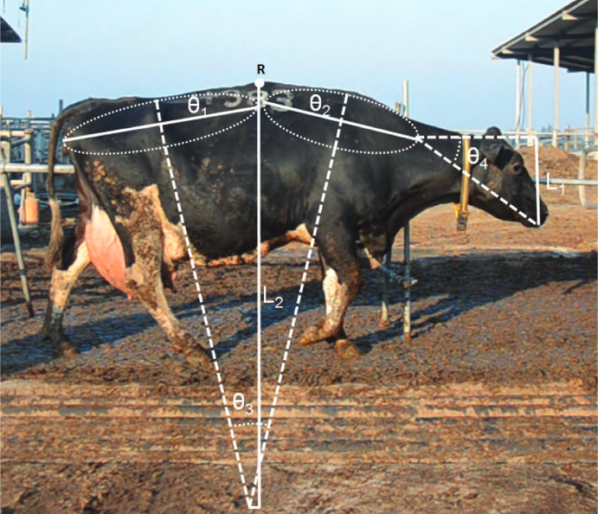

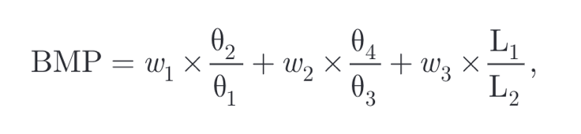Figure1. Equation to estimate the cows BMP

The linear combination of these 4 angles (θ1, θ2, θ3, θ4) and 2 distances (L1, L2) was used to calculate the BMP: where (weight) w1 describes the relationship between the front and back ellipse, w2 includes the relationship between both ellipses and head position, and w3 again relates head position to back curvature. To calculate a BMP value for each cow, the mean of the BMPs calculated every 5 frames was used.

In total, 169 of 223 cases were correctly classified, which is 76% accurate. The results indicate that accuracy is only high when non-lame cow cases are detected. The accuracy of cows classified as non-lame was 83%, while it was only 61% for lame and 64% for severe lame [4].

**3.4 Livestock Detection Based on Convolutional Neural Network**

To maintain the ecological balance of the grassland and obtain the number of grazing animals, an improved livestock detection algorithm based on a full convolutional neural network is proposed.

If the density of grazing livestock in the grassland is too large and exceeds the regulatory capacity of the ecosystem, it will cause overgrazing and lead to the degradation of the grassland. Reducing grazing density in grasslands has become a method to effectively prevent overgrazing and realize natural grassland protection. Therefore, it is of great importance to use livestock detection technology to obtain the grazing amount of grassland accurately and efficiently.

The paper proposes image detection algorithms. Based on the livestock detection algorithm mentioned in the literature, MultiResUNet is proposed to obtain different scales of the image, obtain the layered image patches, and take the candidate regions by morphological operation. An accuracy of 95.37% is obtained.[5].

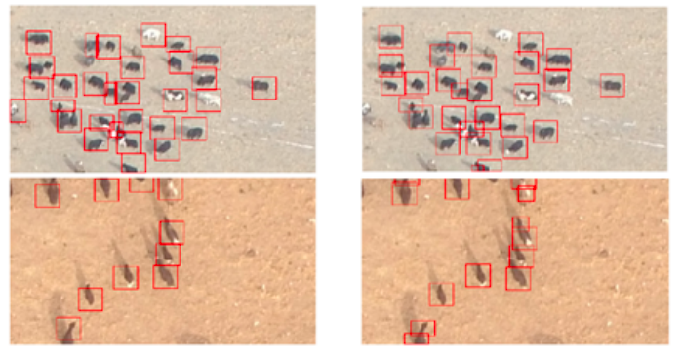

Figure2. Result of the image detection algorithm [5]

## **3. MATERIALS AND METHODS**

In this section, we explain how the data was collected and processed and, after different image-compression algorithm alternatives to solve improve animal-health classification.

## **3.1 Data Collection and Processing**

We collected data from Google Images and Bing Images divided into two groups: healthy cattle and sick cattle. For healthy cattle, the search string was “cow”. For sick cattle, the search string was “cow + sick”.

In the next step, both groups of images were transformed into grayscale using Python OpenCV and they were transformed into Comma Separated Values (CSV) files. It was found out that the datasets were balanced.

The dataset was divided into 70% for training and 30% for testing. Datasets are available at [https://github.com/mauriciotoro/ST0245-Eafit/tree/master/proyecto/dataset](https://github.com/mauriciotoro/ST0245-Eafit/tree/master/proyecto/datasets)s.

Finally, using the training data set, we trained a convolutional neural network for binary image-classification using Google Teachable Machine available at <https://teachablemachine.withgoogle.com/train/image>.

## **3.2 Lossy Image-compression alternatives**

## In what follows, we present different algorithms used to compress images.

**3.2.1 Stream carving**

Seam carving is an intelligent image resizing algorithm to adapt the image content to the screen without distorting important objects. It is an efficient approach to image resizing by removing unimportant pixels using gradient information and dynamic programming [6] The algorithm receives an image, then, calculates the weight/density/energy of each pixel, this is done by an algorithm called gradient magnitude and from the energy, makes a list of seams.

The seams are sorted by energy, with low energy seams being of less importance to the image content. The algorithm removes the low energy seams as necessary and finally returns the image. Seam carving also allows manual definition of areas where pixels cannot be modified and can remove entire objects from photographs.

Stream carving, based on the seam carving algorithm, can now introduce larger seams into the resized image, i.e., seams with a width greater than one pixel, which they call streams.

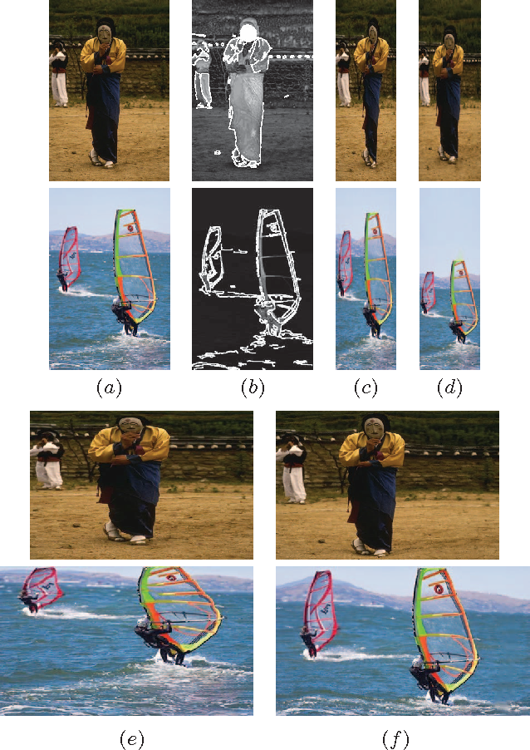

Figure 3. Stream carving algorithm process [7]

The resulting gaps are recovered with an inpainting method. The algorithm uses an adaptive importance map that combines several features, such as gradient magnitude, faces, edge and straight lines detection. This approach induces an increase in the quality of the retargeted image compared to the original seam carving method and provides similar or better results than other current image retargeting techniques. The results of this approach are similar to or better than other current image retargeting techniques. [7]

**3.2.2 Discrete cosine transform (Discrete cosine transform)**

First proposed by Nasir Ahmed in 1972, it is a transformation technique widely used in signal processing and data compression in digital media, including images (such as JPEG and HEIF), digital video (such as MPEG and H.26x), Digital Audio (such as Dolby Digital, MP3 and AAC), Digital TV (SDTV, HDTV and VOD) and Digital Radio (AAC+ and DAB+), as well as in voice coding (AAC-LD, Siren and Opus).

Like any Fourier-based transform, DCTs express a function or a signal in terms of a sum of sinusoids with different frequencies and amplitudes. Like the Discrete Fourier Transform (DFT), a DCT operates on a function at a finite number of discrete data points. The main difference between DCT and DFT is that the former uses only cosine functions, while the latter uses both cosine and sine functions.

Formal definition: the discrete cosine transform is an invertible linear function, where are the real numbers, or equivalently, an invertible square matrix N x N. In the DCT-I variant, the N real numbers X0, ..., XN-1 are transformed into N real numbers X0, ..., XN-1 according to the formula: [12]



Some authors then multiply the terms X0 and XN-1 by √2, and the terms from X0 and XN-1 by 1/√2 which makes the DCT-I matrix an Orthogonal matrix, if one further multiplies by an overall scale factor of  , but breaks the direct correspondence with a real-even DTF.

There are other similar transformation formulas that give rise to the variants DCT-II, DCT-III, DCT-IV.... Up to DCT-VIII, and there are also the so-called Multidimensional variants

**3.2.3 Fractal compression**

As the name suggests, this is a lossy image compression method based on fractals. The method is suitable mainly for images of nature, taking advantage of the fact that parts of an image often resemble other parts of the same image. Fractal algorithms convert these parts into mathematical data called "fractal codes" that are used to recreate the encoded image.

Mathematically, they can be described as an Iterated Function System (IFS).

**Binary images**: To begin, we take a binary image, which can be considered as a subset of R^2. The IFS is then a set of contraction mappings, f1....fn, 

According to this mapping functions, the IFS describes a two-dimensional set S as the fixed point of the Hutchinson Operator



This is, H is an operator mapping sets to sets, and S is the unique set satisfying H(S) = S. The idea is to construct the IFS such that this set S is the input binary image. The set S can be recovered from the IFS by fixed point iteration: for any nonempty compact initial set Ao, the iteration Ak+1 = H(Ak) converges to S.

The set S is self-similar because H(S) = S implies that S is union of mapped copies of itself:



So, we see the IFS is a fractal representation of S. [13]

**Encoding**

A current problem of fractal image representation is how to choose the f1...fn such that its fixed point approximates the input image, and how to do it efficiently.

An approach for doing it is the following partitioned iterated function system (IPFS):

1. Partition the image domain into range blocks Rj of size s x s
2. For each Rj, search the image to find a block Dj of size 2s x 2s that is very similar to Rj
3. Select the mapping functions such that H(Dj) = Rj for each I

In the second step, find a similar block so that the IFS accurately represents the input image, so it is necessary to consider enough candidates blocks for Dj. But a large search considering many blocks is computationally costly, and therefore PIFS fractal encoding is much slower than DCT and wavelet-based image representation. [14]

**3.2.4 Image scaling**

The basic concept of image scaling is to resample a two-dimensional function on a new sampling grid. Many algorithms have already been proposed for image scaling. The most widely used method is the bilinear method, which is considered a first-order sampling and resampling method. In bilinear, the output pixel value changes linearly according to the sampling position.

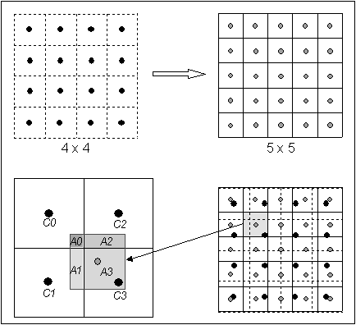

Figure 4. General concept of image scaling

There is a more complex method called bicubic. The weakness of the bilinear and bicubic methods is the blurring effect that causes a poor response at high frequencies [8].

## **3.3 Lossless Image-compression alternatives**

## In what follows, we present different algorithms used to compress images.

**3.3.1 Burrows-Wheeler Transform (BWT)**

Also called Block-sorting compression, is an algorithm used to prepare data to be used with a data compression technique such as bzip2. [15]

When a string of characters is transformed using this algorithm, the transformation "permutes" the order of the characters. If the original string contains several sub-strings that repeat frequently, then the transformed string will have several places where a single character repeats multiple times in a row. For example:

Input SIX.MIXED.PIXIES.SIFT.SIXTY.PIXIE.DUST.BOXES

Output TEXYDST.E.IXIXIXXSSMPPS.B..E.S.EUSFXDIIOIIIT

The Output is easier to compress as it has many repeated characters. In this example, the transformed string contains 6 sets of identical characters: XX, SS, PP, ..., II and III which together add up to 13 of the 44 characters in the string.

**Example:**

The transform is done by sorting all the circular shifts of a text in lexicographic order and by extracting the last column and the index of the original string in the set of sorted permutations S.

Given an input string S = ^BANANA|, rotate it N times, where N = 8 is the length of the S string including the symbol ^, representing the start of the string and the red | character representing the EOF pointer; these rotations, or circular shifts, are then sorted lexicographically. The output of the encoding phase is the last column, L = BNN^AA|A and the index I of the row containing the original string S, in this case I = 6.

|  |  |  |  |  |
| --- | --- | --- | --- | --- |
|  |  | **Transformation** |  |  |
| **1.Input** | **2.All Rotations** | **3.Sort into lexical order** | **4.Take the last column** | **5.Output** |
| ^BANANA| | ^BANANA|  |^BANANA  A|^BANAN  NA|^BANA  ANA|^BAN  NANA|^BA  ANANA|^B  BANANA|^ | **A**NANA|^B  **A**NA|^BAN  **A**|^BANAN  **B**ANANA|^  **N**ANA|^BA  **N**A|^BANA  **^**BANANA|  **|**^BANANA | ANANA|^**B**  ANA|^BA**N**  A|^BANA**N**  BANANA|**^**  NANA|^B**A**  NA|^BAN**A**  ^BANANA**|**  |^BANAN**A** | BNN^AA|A |

The following pseudocode gives a simple way to calculate the BWT and its inverse. It assumes that the input string s contains a special character EOF which is the last character and occurs nowhere in the text:

|  |
| --- |
| **function** BWT (string s)  create a table, where the rows are all possible rotations of s  sort rows alphabetically  **return** (last column of the table) |
| **function** inverse BWT  create empty table  **repeat** length(s) **times**  **//** first insert creates first column  insert s as a column of table before first column of the table  sort rows of the table alphabetically  **return** (row that ends with the EOF character) |

**Dynamic Burrows-Wheeler transform:**

When a text is edited, its Burrows-Wheeler transform will change. Salson et al [16] proposes an algorithm that deduces the Burrows-Wheeler transform of an edited text from that of the original text, doing a limited number of local reordering in the original Burrows-Wheeler transform, which can be faster than constructing the Burrows-Wheeler transform of the edited text directly.

The Time Complexity of the code is O(n2 Log n) because the method builds a suffix array which with O(n) time for strings comparisons, and O(n Log n) for the sorting algorithm.

**3.3.2 LZ77 and LZ78**

Also known as LZ1 and LZ2, are two lossless data compression algorithms, published by Abraham Lempel in 1977 [17] and Jacob Ziv in 1978 [18]. They form the basis of many variants, including LZW, LZSS, LZMA and others. They are the basis of such general systems as GIF and DEFLATE, the latter used in PNG and ZIP.

LZ77 performs compression by replacing repeated occurrences of data with a reference to a single copy of that repeated data existing in the original uncompressed data. A match is encoded with a pair of numbers called a "length-distance pair" equivalent to the following phrase: "each of the following length characters is equal to exactly the previous length-distance characters in the original uncompressed data."

To detect matches, the program must keep a record of a certain amount of the most recent data, for example, the last 2KB, 4KB or 32KB. The structure in which this data is stored is called a sliding window, which is why LZ77 is also known as sliding window compression.

The following is the pseudocode of the algorithm:

while input is not empty do

prefix := longest prefix of input that begins in window

if prefix exists then

d := distance to start of prefix

l := length of prefix

c := char following prefix in input

else

d := 0

l := 0

c := first char of input

end if

output (d, l, c)

discard *l* + 1 chars from front of window

s := pop *l* + 1 chars from front of input

append s to back of window

repeat

The LZ78 performs compression by replacing repeated occurrences of data with references to a dictionary that is constructed based on the input data. Each dictionary entry is of the form

Dictionary[...] = {index, character}

Where index is the index to a previous dictionary entry and character is appended to the end of the string represented by dictionary[index]. For example, "abc" will be stored (in reverse order), as follows:

Dictionary[k] = {j, 'c'}, dictionary[j] = {i,'b'},dictionary[i]={0,'a'}

Where index 0 represents the first character of a string. The algorithm initializes last matching index = 0 and next available index = 1. For each character in the input string, the dictionary is searched for a match: {last matching index, character}. If a match is found, then last matching index is matched to the index of the matching input, and there is no output. If no match is found, a new dictionary entry is created: dictionary{next available index} = {last matching index, character}, and the algorithm writes last matching index followed by character, makes last matching index = 0 and increments next available index. When the dictionary is full no new entries are added. When the end of the input data is reached, the algorithm writes last matching index. The strings are stored in reverse order, which the decoder must consider.

The complexity of the algorithm was calculated as: O(n (1 + log s / log log n), where s = O(1), by Paolo Ferragina, Igor Nitto and Rossano Venturini, “On the bit-complexity of Lempel-Ziv compression”

**3.3.3 Huffman coding**

Huffman coding is a lossless data compression algorithm. The idea is to assign variable length codes to the input characters; the lengths of the assigned codes are based on the frequencies of the corresponding characters. The most frequent character receives the smallest code and the least frequent the largest.

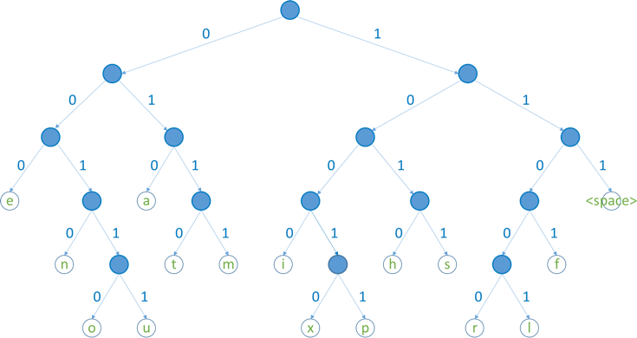

Figure 5. Huffman tree generated from the exact frequencies of the text "this is an example of a Huffman tree". Encoding the sentence with this code requires 135 bits, as opposed to 288 (or 180) bits if 36 characters of 8 (or 5) bits were used. [10]

Variable-length codes assigned to input characters are prefixed codes, meaning that the codes (bit sequences) are assigned in such a way that the code assigned to one character is not the prefix of the code assigned to any other character. This is how Huffman coding ensures that there is no ambiguity when decoding the generated bit stream. The complexity is O(nlogn) where n is the number of unique characters. [9]

**3.3.4 Delta encoding**

This algorithm represents compressed pixel streams as the difference between the current and previous pixel.

The first pixel in the delta-encoded file is the same as the first pixel in the original image. All subsequent pixels in the encoded file are equal to the difference (delta) between the corresponding value of the input image and the previous value of the input image. In other words, delta coding increases the probability that the value of each pixel is close to zero and decreases the probability that it is far from zero [11].

**Bibliography in the next page.**

[1] Berckmans D. (2014). Precision livestock farming technologies for welfare management in intensive livestock systems. *Revue scientifique et technique (International Office of Epizootics)*, *33*(1), 189–196. <https://doi.org/10.20506/rst.33.1.2273>

[2] PIERS Online, Vol 5, No. 1, 2009: Kae Hsiang Kwong, Tsung Ta Wu, Hock Guan Goh, Bruce Stephen, Michael Gilroy, Craig Michie and Ivan Andonovic. Tomado de: [Vol5No1Page31to35.pdf(piers.org)](https://www.piers.org/piersonline/pdf/Vol5No1Page31to35.pdf)

[3] Precision Livestock Farming: An international Review of scientific and commercial aspects (T M Banhazi, H Lehr, J L Black, H Crabtree, P Schofield, M Tscharke, D Berckmans. Tomado de <http://ijabe.org/index.php/ijabe/article/view/599/498>

[4] Viazzi, Stefano & Bahr, C. & Schlageter Tello, Andres & Van Hertem, Tom & Romanini, C.E.B. & Pluk, Arno & Halachmi, Ilan & Lokhorst, C & Berckmans, Daniel. Analysis of individual classification of lameness using automatic back posture measurement in dairy cattle. Journal of dairy science, 2012, 96. 10.3168/jds.2012-5806.

[5] Chao Zuo, Liang Han, Pin Tao, and Xiang lei Meng. 2020. Livestock Detection Based on Convolutional Neural Network. In 2020 the 3rd International Conference on Control and Computer Vision (ICCCV'20). Association for Computing Machinery, New York, NY, USA, 1–6.

[6]DOI:https://doi.org/10.1145/3425577.3425578 Wikipedia contributors. (2020, 7 November).Seam carving.Wikipedia.https://en.wikipedia.org/wiki/Seamcarving

[7]Domingues, D., Alahi, A., & Vandergheynst, P. (2010). *Stream carving: An adaptive seam carving algorithm. 2010 IEEE International Conference on Image Processing.* doi:10.1109/icip.2010.5653984

[8] Chun-Ho Kim, Si-Mun Seong, Jin-Aeon Lee and Lee-Sup Kim, "Winscale: an image-scaling algorithm using an area pixel model," in IEEE Transactions on Circuits and Systems for Video Technology, vol. 13, no. 6, pp. 549-553, June 2003, doi: 10.1109/TCSVT.2003.813431.

[9] GeeksforGeeks. “Huffman Coding | Greedy Algo-3.” *GeeksforGeeks*, 23 Mar. 2021, [www.geeksforgeeks.org/huffman-coding-greedy-algo-3](http://www.geeksforgeeks.org/huffman-coding-greedy-algo-3).

[10] Ghent University. “Huffman Coding.” *Dodona*, 2021, dodona.ugent.be/en/activities/601074743.

[11] Wahba, Walaa Z,& Maghari, Ashraf Y. A. (2016). Lossless Image Compression Techniques Comparative Study. International Research Journal of Engineering and Technology (IRJET), e-ISSN 2395-0056, Volume: 3, Number: 2, <http://hdl.handle.net/20.500.12358/25131>

[12] Ahmed, Nasir; Natarajan, T. ; Rao, K.R. (January 1974), Discrete Cosine Transform, IEEE Transactions on Computers, C-23 (1): 90-93. doi: 10.1109/T-C. 1974.223784

[13] May, Mike (1966). “Fractal Image Compression”. *American Scientist*. **84** (5): 442-451. Bibcode: 1966AmSci..84..442

[14] Saupe, Dietmar; Hamazaoui, Raouf (November 1994). “A review of the fractal image compression literature” *ACM SIGGRAPH Computer Graphics.* **28** (4): 268-276. doi:10.1145/193234.193246

[15] Burrows, Michael; Wheeler, David J. (1994), *A block sorting lossless data compression algorithm,* Technical Report 124, Digital Equipment Corporation

[16] Salson M , Lecroq T, Leonard M, Mouchard L (2009). “A Four-Stage algorithm for updating a Burrows-Wheeler transform”. *Theoretical Computer Science.* **410** (43): 4350-4359. doi:10.1016/j.tcs.2009.07.016

[17] Ziv, Jacob; Lempel, Abraham (May 1977). “A universal algorithm for Sequential Data Compression” *IEEE Transactions on Information Theory.* **23** (3): 337-343. CiteSeerX 10.1.1.118.8921. doi:10.1109/TIT.1977.1055714

[18] Ziv, Jacob; Lempel, Abraham (September 1978). “Compression of individual sequences via Variable-Rate coding”. *IEEE Transactions on Information Therory.* **24** (5) : 530-536. CiteSeer X 10.1.1.14.2892

[19] Andonovic, Ivan; Michie, Craig; Gilroy, Michael; Guan Goh, Hock; Hsiang Kwong, Kae; Sasloglow, Konstantinos; Wu, Tsungta. “Wireless sensor networks for cattle Health Monitoring”. Centre for Dynamic Communication, Department of Electronic and Electrical Engineering, University of Strathclyde, 204 George Street, Glasgow, United Kingdom.doi: 10.1007/978-3-642-10781-8_3

[20] Smith, Kevin; Martinez, Angel; Craddolph, Roland; Erickson, Howard; Andresen, Daniel; Warren, Steve. “An Integrated Cattle Health Monitoring System”, IEEE, (2006), doi 10.1109/IEMBS.2006.259693

Hasta aquí la entrega uno. En las 3 páginas siguientes se conservan las plantillas para las entregas futuras.

## **4. ALGORITHM DESIGN AND IMPLEMENTATION**

## In what follows, we explain the data structures and the algorithms used in this work. The implementations of the data structures and algorithms are available at Github[1].

## **4.1 Data Structures**

## Explain the data structure used to make the image compression and make a figure explaining it. Do not use figures from the Internet. *(In this semester, example of the data structures are trees and hash tables)*

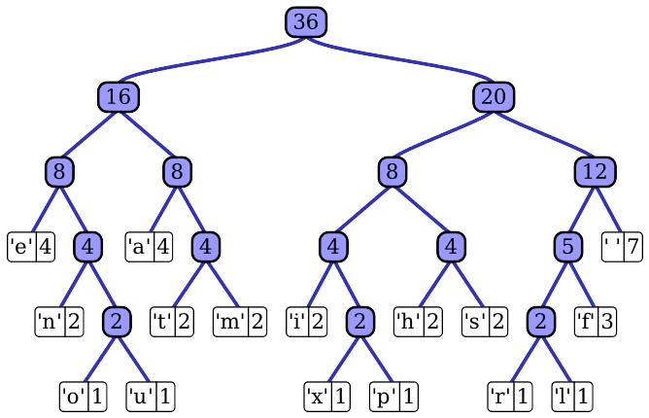**Figure 1:** Huffman tree generated from the exact frequencies of the text "this” (Please, feel free to change this Figure if you use a different data structure).

**4.2 Algorithms**

In this work, we propose a compression algorithm which is a combination of a lossy image-compression algorithm and a lossless image-compression algorithm. We also explain how decompression for the proposed algorithm works.

Explain the design of the algorithms to solve the problem and make a figure. Do not use figures from the Internet, make your own. *(In this semester, one algorithm must be a lossy image-compression algorithm such as image scaling, seam carving or wavelet compression and the second algorithm must be a lossless image-compression algorithm such as Huffman coding, LZS or LZ77).*

**4.2.1 Lossy image-compression algorithm**

Explain, briefly, how did apply a lossy image-compression algorithm such as seam carving or image scaling. Explain also decompression.

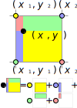**Figure 2:** Image scaling using bi-lineal interpolation. (Please, feel free to change this Figure if you use a different data structure).

**4.2.2 Lossless image-compression algorithm**

Explain, briefly, how did you apply a lossless image-compression algorithm such as Huffman coding, LZS or LZ77. Explain also decompression.

**4.3** **Complexity analysis of the algorithms**

Explain, in your own words, the analysis for the worst case using O notation. How did you calculate such complexities. Please explain briefly.

|  |  |
| --- | --- |
| **Algorithm** | **Time Complexity** |
| Compression | O(N2*M2) |
| Decompression | O(N3*M*2N) |

**Table 2:** Time Complexity of the image-compression and image-decompression algorithms. *(Please explain what do N and M mean in this problem).*

|  |  |
| --- | --- |
| **Algorithm** | **Memory Complexity** |
| Compression | O(N*M*2N ) |
| Decompression | O(2M*2N) |

**Table 3:** Memory Complexity of the image-compression and image-decompression algorithms. *(Please explain what do N and M mean in this problem).*

**4.4 Design criteria of the algorithm**

Explain why the algorithm was designed that way. Use objective criteria. Objective criteria are based on efficiency, which is measured in terms of time and memory consumption. Examples of non-objective criteria are: “I was sick”, “it was the first data structure that I found on the Internet”, “I did it on the last day before deadline”, etc. Remember: This is 40% of the project grading.

**5. RESULTS**

**5.1 Model evaluation**

In this section, we present some metrics to evaluate the model. Accuracy is the ratio of number of correct predictions to the total number of input samples. Precision. is the ratio of successful students identified correctly by the model to successful students identified by the model. Finally, Recall is the ratio of successful students identified correctly by the model to successful students in the data set.

**5.1.1 Evaluation on training data set**

In what follows, we present the evaluation metrics for the training data set in Table 3.

|  |  |
| --- | --- |
|  | ***Training data set*** |
| *Accuracy* | 0.02 |
| *Precision* | 0.03 |
| *Recall* | 0.01 |

## **Table 3.** Binary image-classification model evaluation on the training data set.

**5.1.2 Evaluation on test data set**

In what follows, we present the evaluation metrics for the testing dataset in Table 4 without compression and, in Table 5, with compression.

|  |  |
| --- | --- |
|  | ***Testing data set*** |
| *Accuracy* | 0.01 |
| *Precision* | 0.012 |
| *Recall* | 0.013 |

## **Table 4.** Binary image-classification model evaluation on the testing data set without image compression.

|  |  |
| --- | --- |
|  | ***Testing data set*** |
| *Accuracy* | 0.001 |
| *Precision* | 0.0012 |
| *Recall* | 0.0013 |

## **Table 5.** Model evaluation on the testing data set with image compression.

**5.2 Execution times**

In what follows we explain the relation of the average execution time and average file size of the images in the data set, in Table 6.

Compute execution time for each image in Github. Report average execution time Vs average file size.

## 

|  |  |  |
| --- | --- | --- |
|  | ***Average execution time (s)*** | ***Average  file size (MB)*** |
| *Compression* | 100.2 s | 12.4 MB |
| *Decompression* | 800.1 s | 12.4 MB |

## **Table 6:** Execution time of the *(Please write the name of the algorithms, for instance, seam carving & LZ77)* algorithms for different images in the data set.

## **5.3 Memory consumption**

We present memory consumption of the compression and decompression algorithms in Table 7.

|  |  |  |
| --- | --- | --- |
|  | ***Average memory consumption (MB)*** | ***Average file size (MB)*** |
| Compression | 634 MB | 3.12 MB |
| Decompression | 9 MB | 878.12 MB |

## **Table 7:** Average Memory consumption of all the images in the data set for both compression and decompression.

## To measure memory consumption, you should use a profiler. A very good one for Java is VisualVM, developed by Oracle, <http://docs.oracle.com/javase/7/docs/technotes/guides/visualvm/profiler.html>. For Python, use C Profiler.

## **5.3 Compression ratio**

We present the average compression ratio of the compression algorithm in Table 8.

|  |  |  |
| --- | --- | --- |
|  | ***Healthy Cattle*** | ***Sick Cattle*** |
| Average compression ratio | 1:23 | 1:34 |

## **Table 8:** Rounded Average Compression Ratio of all the images of Healthy Cattle and Sick Cattle.

## **6. DISCUSSION OF THE RESULTS**

Explain the results obtained. Are precision, accuracy and sensibility appropriate for this problem? Is the model over-fitting? Is memory consumption and time consumption appropriate? Is compression ratio appropriate? Does compression changes significantly precision on the test data set? *(In this semester, according to the results, can this improve animal-health classification in the context of PLF?)*

**6.1 Future work**

Answer, what would you like to improve in the future? How would you like to improve your algorithm and its implementation? What about using discrete cosine transform or wavelet compression?

# **ACKNOWLEDGEMENTS**

Identify the kind of acknowledgment you want to write: for a person or for an institution. Consider the following guidelines: 1. Name of teacher is not mentioned because he is an author. 2. You should not mention websites of authors of articles that you have not contacted. 3. You should mention students, teachers from other courses that helped you.

As an example: This research was supported/partially supported by [Name of Foundation, Grant maker, Donor].

We thank for assistance with [particular technique, methodology] to [Name Surname, position, institution name] for comments that greatly improved the manuscript.

# **REFERENCES**

1. <http://www.github.com/> ????????? /proyecto/